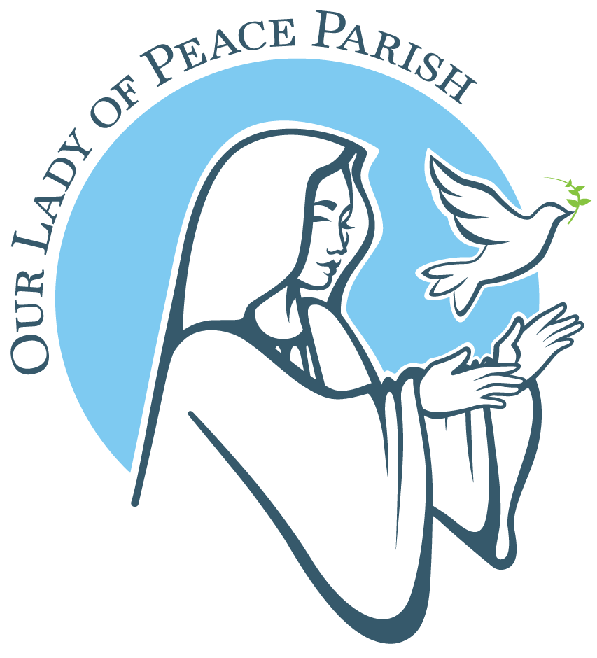
Our Lady of Peace Parish
Pastoral Care Center
603 Union St.
Fredericton, NB E3A 3N5
Tel: (506) 444-6010 Email: parishoffice@ourladyofpeacefredericton.ca

RCIA Registration Form
The personal information collected on this form is confidential and will be used only for pastoral care and sacrament records related to the RCIA process.

Full Name: Click or tap here to enter text.

Date of Birth: Click or tap here to enter text. Place of Birth: Click or tap here to enter text.

CONTACT INFORMATION

Address: Click or tap here to enter text.

Phone: Click or tap here to enter text.

Email: Click or tap here to enter text.

RELIGIOUS HISTORY

Have you ever been baptized (Catholic or any other Christian denomination)?

Yes ☐ No ☐ Not Sure ☐

If yes, where and when? Click or tap here to enter text.

Note: For Catholic baptisms a certificate of baptism with parish contact information must be supplied before receiving any sacraments. Whenever possible baptism certificates from other denomination should also be supplied.

If you were baptized Catholic, please check those sacraments you have received:

☐ Penance and Reconciliation (Confession)

☐ Holy Eucharist (First Communion)

☐ Confirmation

MARITAL STATUS

☐ Single

☐ Married

☐ Separated

☐ Divorced

☐ Divorced/Remarried

☐ Nullity of Marriage

☐ Widow/Widower

